Project Design Phase
Solution Architecture

Date | 15 February 2025
Team ID | 6ab3db806603573ccfb383f7
Project Name | AI FAQ Assistant
Maximum Marks | 4 Marks

Solution Architecture – AI FAQ Assistant
Solution architecture for the AI FAQ Assistant is a structured process that connects user requirements with the appropriate software and technology solutions. It defines how the system is designed, developed, integrated, and delivered to provide quick and relevant answers to frequently asked questions. Its goals are to:
● Identify suitable technologies to develop an efficient and user-friendly AI FAQ Assistant.
● Describe the structure, components, and functionality of the AI FAQ Assistant to the development team and project stakeholders.
● Define system features, development phases, and technical requirements needed to build the AI FAQ Assistant.
● Provide clear technical specifications for developing, managing, testing, and delivering the AI FAQ Assistant solution.
Available next action: Create a downloadable DOCX file here in this chat containing the editable prose above

Example - Solution Architecture Diagram:

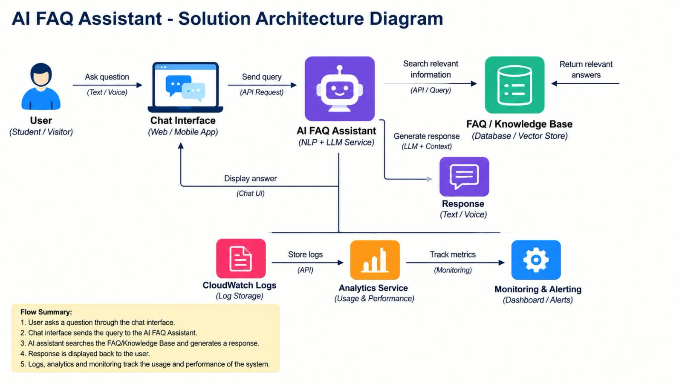
Figure 1: Architecture and data flow of the voice patient diary sample application

